2019 OSAC Enhancement

using IBM Content Navigator

Last updated on 3/20/2019

Last updated by Sungwook Kwon

# Requirements

Referenced from GPR V1.1 (4/3/2010)

The customer is requesting a solution that allows their unit to reduce the amount of paper being physically stored.

O.S.A.C. would like the capability to:

* Create a new record for an apprentice or apprenticeship program
* Update an existing record
* Search for an individual apprentice, apprenticeship program, or document
* Append/associate incoming documents to an existing file
* Create multiple records for an apprentice (if he/she enters more than one apprenticeship program)
* Retrieve and print a document, for example an apprentice who completed an apprenticeship program and has requested a copy of his/her certificate.

The activities listed above can be accomplished by providing the customer with a solution that allows them to perform the following:

* Log into a system that gives the users levels of permission to view, write, edit, etc.
* Perform searches (Search screen) and view a list of results (Results screen)
* Provide an Intake screen that allows the user to capture data about an Apprentice or Program
* Scan documents into the system
* Associate the scanned document to a record
* Store the documents electronically
* Retrieve and print associated documents.

# Issues with 2010 Implementation

* The data structure was designed in hierarchical structure of 3 levels of folders, a custom object and a document class, which is overly normalized.
* Maintaining these nesting folders in a consistent manner is not convenient.
* User interface is implemented with FileNet Workplace which will be no longer supported from 4/30/2019. ICN will replace Workplace’s role of user interface to FileNet contents.

# Suggestions in 2019 Implementation

## Changes in features

* The data structure will be simplified with a folder class and a document class which is very straightforward folder system in real life.
* Maintaining these nesting folders in a consistent manner is not convenient.
* User interface is implemented with FileNet Workplace which will be no longer supported from 4/30/2019. ICN will replace Workplace’s role of user interface to FileNet contents.
* The way how to access the existing content will be implemented in ICN as well.
* New workflow will be introduced and explained to the users.

## RAPIDS

RAIDS – Registered Apprenticeship Partners Information Data System.

RAPIDS is the system of record for Apprenticeship Program. It consists with Program and Apprentices.   
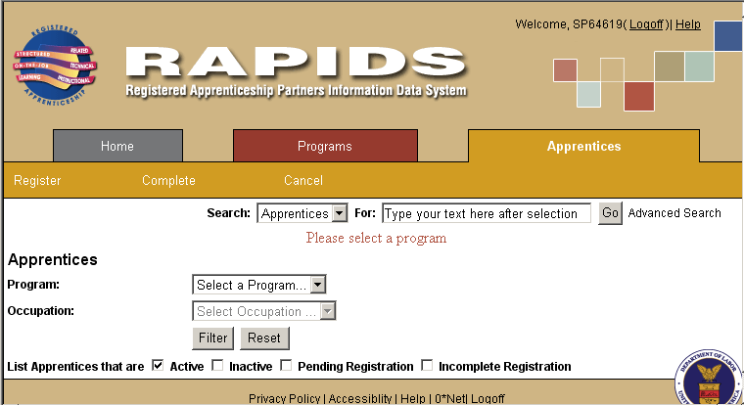

Therefore, it would make more sense we construct JFS’ data structure along with this system.

## Data Structure – Folder & Document

Users will enter all meta data of sponsor and program to RAPID when they register a new program. RAPID will generate an ID and assign to the program.

If we want, FileNet will keep the same meta data as folder or document properties. In that case, users will need to enter the same data again to FileNet. However, this would help users to use the information and contents without RAPIDS.

|  |  |
| --- | --- |
| Apprentice Program Folder |  |
| **Property Category** | **Display Name** |
| Sponsor | OAC Sponsor Name |
| Address Line1 |
| Address Line2 |
| City |
| State |
| Zip Code5 |
| OAC County |
| Phone |
| Fax |
| Program | OAC Program ID |
| OAC Program Name |
| OAC Program Status |
| OAC Occupations |
| OAC Approval Date |
| OAC Termination Date |

|  |  |
| --- | --- |
| **Apprentice Program Document** | |
| **Property Category** | **Display Name** |
| Case | OAC Program ID |
|  | OAC Document Type |
|  |  |
|  |  |
| **Apprentice Document** | |
| **Property Category** | **Display Name** |
| Case | OAC Program ID |
|  | OAC Document Type |
|  | OAC Registration Date |
|  | OAC Completion Date |
|  | OAC Completion Reason |
| Apprentice | OAC Apprentice ID |
|  | First Name |
|  | Middle Initial |
|  | Last Name |
|  | Gender |
|  | DOB |
|  | Address Line1 |
|  | Address Line2 |
|  | City |
|  | State |
|  | Zip Code5 |

Otherwise we will just include program ID and apprentice ID as a key to map the documents in FileNet to a program or apprentice in RAPIDS. In this case, users will enter two ID only; Program ID and/or Apprentice ID.

|  |  |
| --- | --- |
| **Apprentice Program Document** | |
| **Property Category** | **Display Name** |
| Case | OAC Program ID |
|  | OAC Document Type |
| **Apprentice Document** | |
| **Property Category** | **Display Name** |
| Case | OAC Program ID |
|  | OAC Apprentice ID |
|  | OAC Completion Date |

